Questions and Exercises to work out and turn in:

Grading Guidelines (See Appendix):

A right answer will get full credit when:

1. It is right (worth 25%)
2. It is right **AND** neatly presented making it easy and pleasant to read. (worth an **extra** 15%)
3. There is an **obvious and clear link[1]** between 1) the information provided in the exercise and in class and 2) the final answer. A clear link is built by properly writing, justifying, and documenting an answer (worth an **extra** 60%).
4. Calculation mistakes will be minimally penalized (2 to 5% of full credit) while errors on units will be more heavily penalized.

**Late Submission** : as specified in the syllabus. Day counting starts one minute after the deadline.

**Check Your Submission:**  after submitting, download your submission to check whether it is the right version and it is complete.

You are welcome/encouraged to discuss exercises with other students or the instructor. But, ultimately, **personal** writing is expected.

* USE THIS FILE AS THE STARTING DOCUMENT YOU WILL TURN IN. **KEEP IN THE QUESTIONS** AND INSERT YOUR ANSWERS.
* IF USING HAND WRITING (STRONGLY DISCOURAGED), REWRITE THE QUESTIONS.
* FAILING TO FOLLOW TURN IN DIRECTIONS /GUIDELINES WILL COST A 30% PENALTY.

Objectives of this assignment:

* to get a sense of round-trip time of packets over the network
* to explore the topology of the Internet.

What you need to do:

Answer the questions and/or solve the exercises described below.

Exercise 1 (100 points)

The ping program allows you to send a test packet to a given location and see how long it takes to get there and back. Try using ping to see how long it takes to get from your location to several known locations. From these data, plot the one-way transit time over the Internet as a function of distance. The ping provides the round-trip time. Half the minimum[2] round trip time is in general a reasonable estimate of the one-way transit time. It is best to use universities since the location of their servers is *in* *general* known very accurately. For example, www.usc.edu is in Los Angeles, California; www.washington.edu is in Seattle, Washington; scu.edu.au (*Southern Cross University*, Australia); www.mcgill.ca is in Montreal, Canada; and www.hec.edu is in Jouy-en-Josas (Paris), France.

Add three other universities of your choice in three continents other than North America (must respond to your pings).

(25 points) Provide **one** **screenshot** (*document*) of ONE ping command to www.hec.edu. Insert the screenshot in this document. The screenshot should show at least 5 responses (to the ping command). **Your screenshot should look like this template screenshot (we should see the username, the date, the commands typed, and the results)**: Failing to post the screenshot or not providing all the required information will result in a 50 points penalty. Providing a screenshot of this task on your local machine will result in a 50 points penalty.

Proof of ONE ping command to [www.hec.edu](http://www.hec.edu). I included the date command as well in the screenshot to show the TUX machine I was logged onto and then the time. I had pinged to my other required locations for using in the next part of the assignment before this screenshot.

**Do not hesitate to ask for help on Piazza if you encounter any problem to log onto engineering Tux machines.**

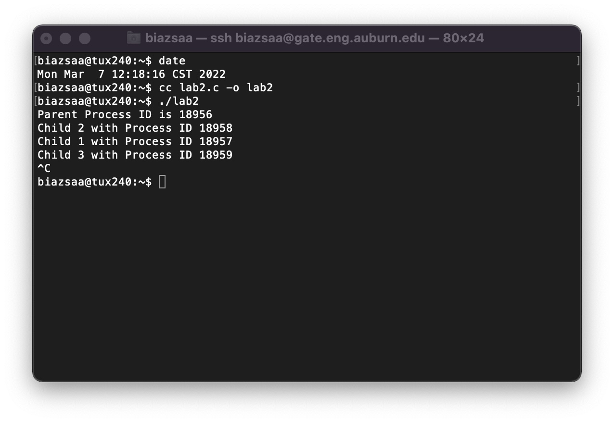

(45 points) The objective is to explore the relationship between the distance and the one-way transit time. Plot the one-way time (y-axis) versus the distance (x-axis). Note that a bar graph is inappropriate if the x-axis represents the distance from Auburn to the universities. Pinpoint (label) each distance with the name/hostname of the locations (all universities provided and the three universities you provide.

Here I made two different versions of the same scatterplot graph. One only has 4 and the other has 6. This should be from a number of different regions in the world. Understand I tried to do multiple from Africa and could never establish a ping and would always return 100% packet loss.

(30 points) Discuss the plot. Does the one-way transit correlate with the distance? If not, why?

www.harvard.edu (Cambridge, Massachusetts, USA): Short distance and low one-way transit time, indicating a relatively fast connection.

www.nus.edu.sg (Singapore): Long distance but with a relatively low one-way transit time, suggesting an efficient connection.

www.usc.edu (Los Angeles, California): Indicates a relatively fast connection.

www.mcgill.ca (Montreal, Canada): As expected, the longer distance results in a higher transit time.

www.hec.edu (HEC Paris, Jouy-en-Josas, France): A moderate distance and one-way transit.

The plot does show a general trend where longer distances tend to have higher one-way transit times. However, there are variations, and the relationship is not perfectly linear. Factors such as network infrastructure, routing efficiency, and server performance can contribute to deviations from a strict distance correlation. There is a tendency for one-way transit time to increase with distance, but it's not a direct and proportional correlation. The scatter plot provides a visual representation of the data, offering insights into the complex relationship between distance and one-way transit time but this does not show all the problems that can be caused. In addition to the observed trend of longer distances generally correlating with higher one-way transit times, it's crucial to recognize that the relationship is influenced by multifaceted factors beyond geographical distance alone. The deviations from a strict linear correlation underscore the impact of intricate elements such as network infrastructure, routing efficiency, and server performance. These complexities contribute to variations in transit times, making it clear that the relationship between distance and one-way transit time is not solely determined by geographical proximity. The scatter plot offers valuable insights into the intricate interplay of these factors, emphasizing the intricate nature of the connection between distance and one-way transit time. It's important to note that challenges in data collection, as experienced in attempts to ping multiple university websites in Africa, further underscore the complexities and limitations in drawing absolute conclusions.

**In case you are not in Auburn**,

There are many ways you can complete this exercise. Here are two of them:

**Method 1**:

Log in remotely on the Engineering Tux machines to ping. To log in remotely, you must use an ssh client such as SecureCRT (Windows).

On Windows 10, you may use from the command prompt the following command (if ssh is available):

ssh username@gate.eng.auburn.edu

where username is your Auburn University username.

On Mac or any Unix machine (Ubuntu...), use the same command (see above) on a terminal.

**Method 2**:

Use a virtual desktop at:  <https://rdp.eng.auburn.edu/>

**If you have any issue to log in remotely to Tux machines, ask on Piazza for help: the instructor, TA and classmates can help.**

What you need to turn in:

* Electronic copy of this file (including your answers) (standalone). Submit the file as a Microsoft Word or PDF file.
* Recall that answers must be well written, documented, justified, and presented to get full credit.
* How this assignment will be graded:
* A right answer will get full credit when:
* It is right (worth 25%)
* It is right AND neatly presented making it easy and pleasant to read. (worth 15%)
* There is an obvious and clear link between 1) the information provided in the exercise and in class and 2) the final answer. A clear link is built by properly writing, justifying, and documenting an answer (worth 60%).
* Calculation mistakes will be minimally penalized (2 to 5% of full credit) while errors on units will be more heavily penalized.
* You are welcome/encouraged to discuss exercises with other students or the instructor. But, ultimately, personal writing is expected.

**Appendix**: Grading: What is an OBVIOUS and CLEAR LINK?

Here is an example to explain what an **obvious and clear link** is and how we grade your work.

Consider the following problem:

"(100 points) John travels from Auburn to Atlanta in his car at a speed of 60 mph. Leaving at 8am, at what time will John reach Atlanta".

Here are the answers of three students and their scores:

* **Student 1** answers: "9:48am". Student 1 will get 25 points.
* **Student 2**answers : "John will reach Atlanta at 9:48am". Student 2 will get 25+15 = 40 points
* **Student 3** answers: "The time t to travel a distance d at speed v is equal to d/v = d/60mph. The problem does not provide the distance d from Auburn to Atlanta. Based on GoogleMaps, the distance from Auburn to Atlanta is approximately 108 miles (**document is attached HERE near the justification**).

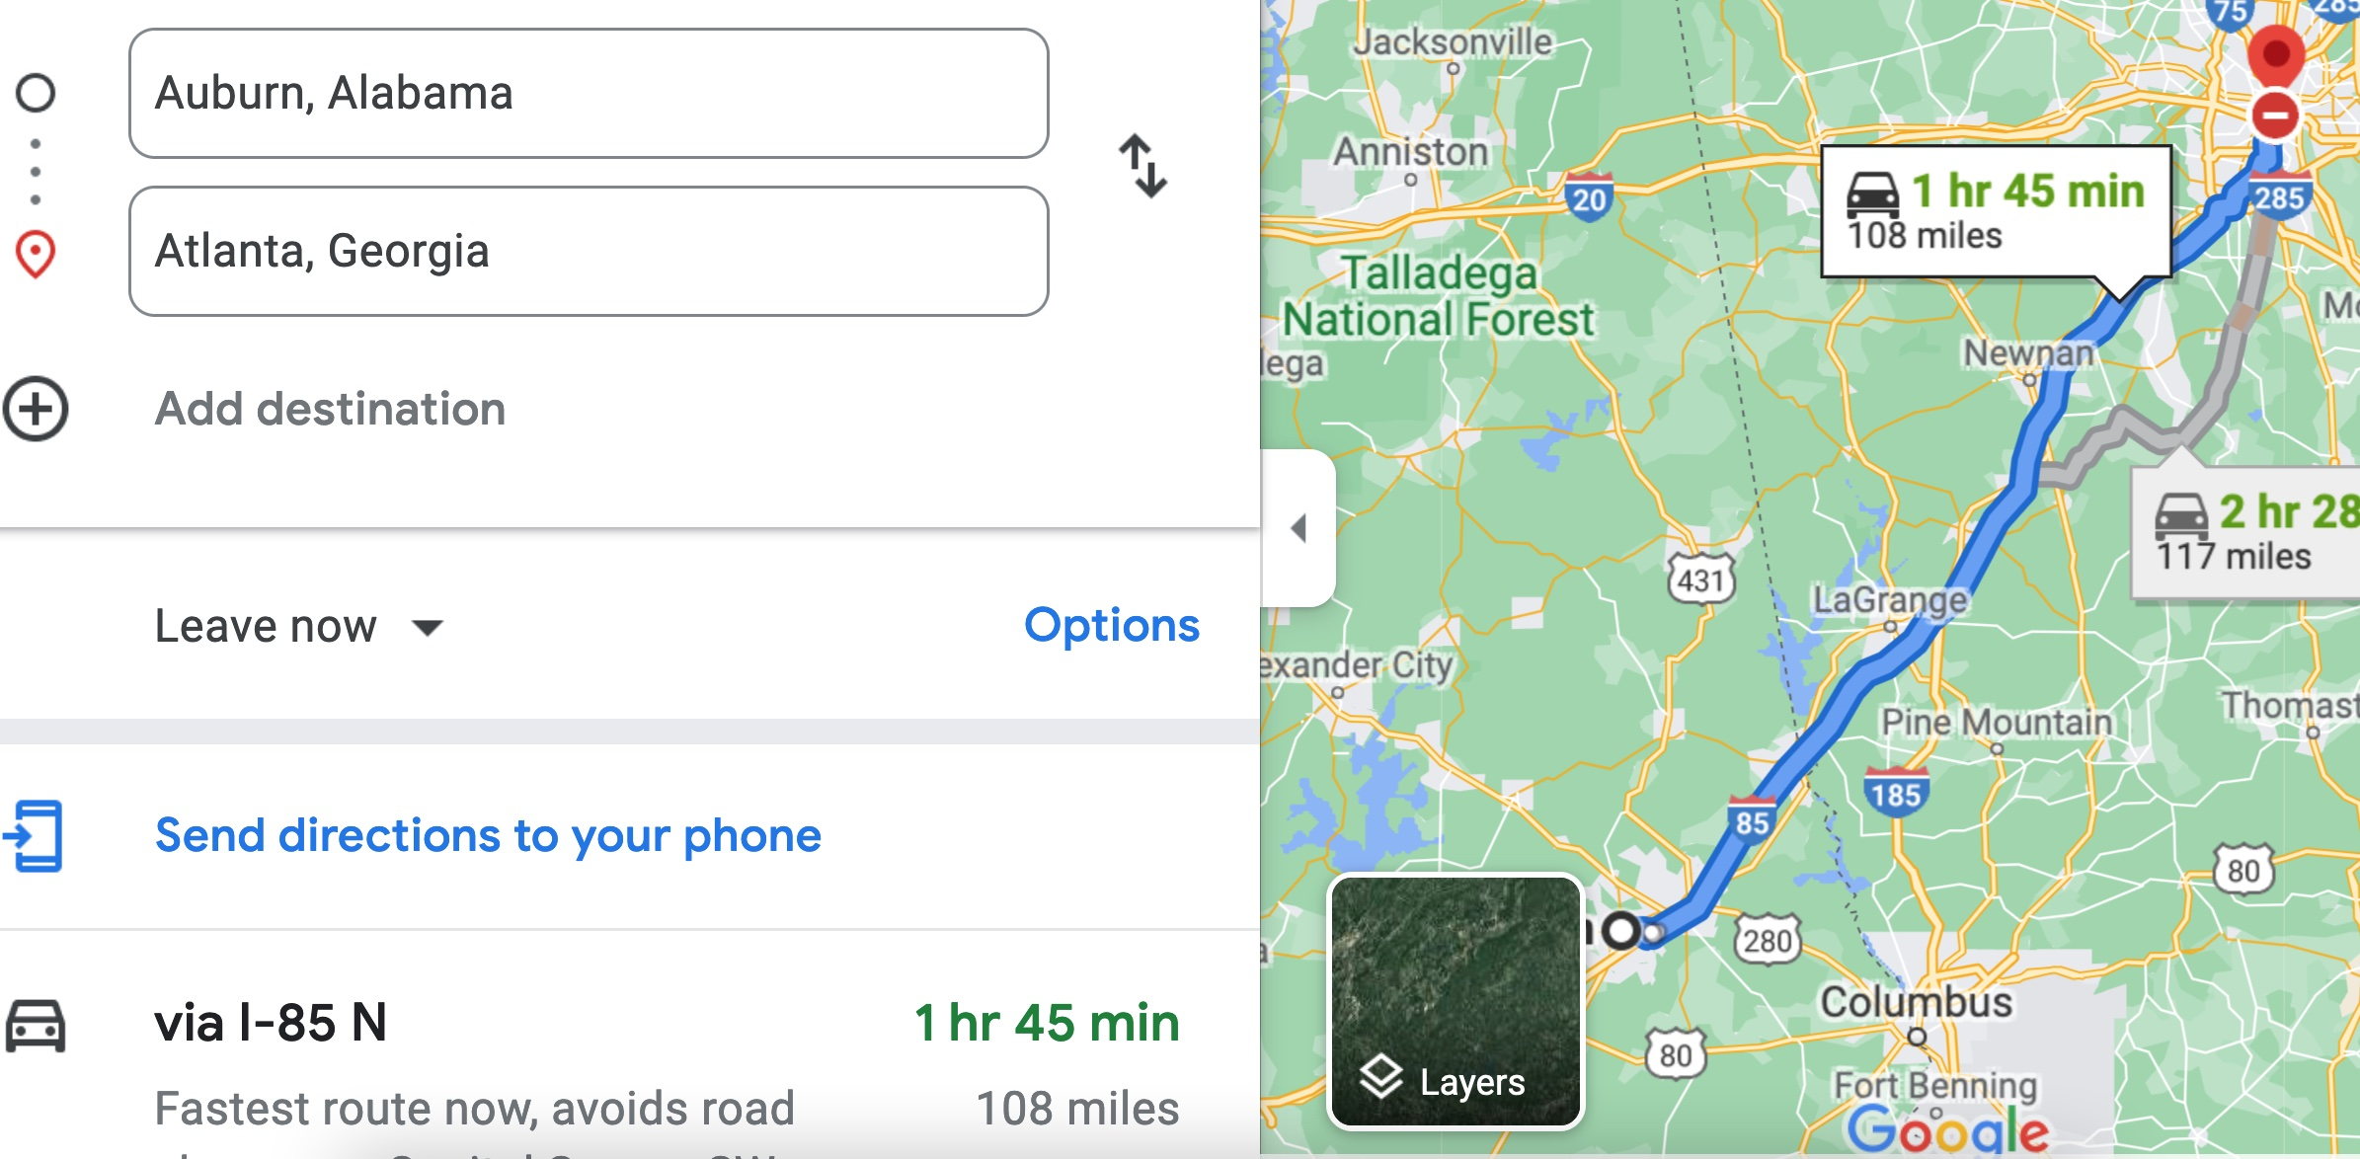

Therefore, the time t = 108 miles/60mph * 60 minutes/hour= 108 minutes. Since John left at 8am, he will then reach Atlanta at 8am + 108 minutes = 8 am + 60 minutes + 48 minutes = 9:48".

**Student 3** will get 25 + 15 + 60 = 100 points

Do you see the **direct** **link** going from the data provided in the question to the final answer, using general knowledge/formula and documents?.... Can you now solve the following problem and get 100 points?

"(100 points) Alice travels from Auburn to Atlanta in her car at a speed of 60 mph. Leaving at 8am, at what time will Alice reach Atlanta assuming that she had a flat tire that delayed her 30 minutes".

1. See on the appendix what an obvious and clear link is.
2. Smallest round trip time provided by multiple ping packets to the target machine.